**Exercise 1: Database and Table Creation**

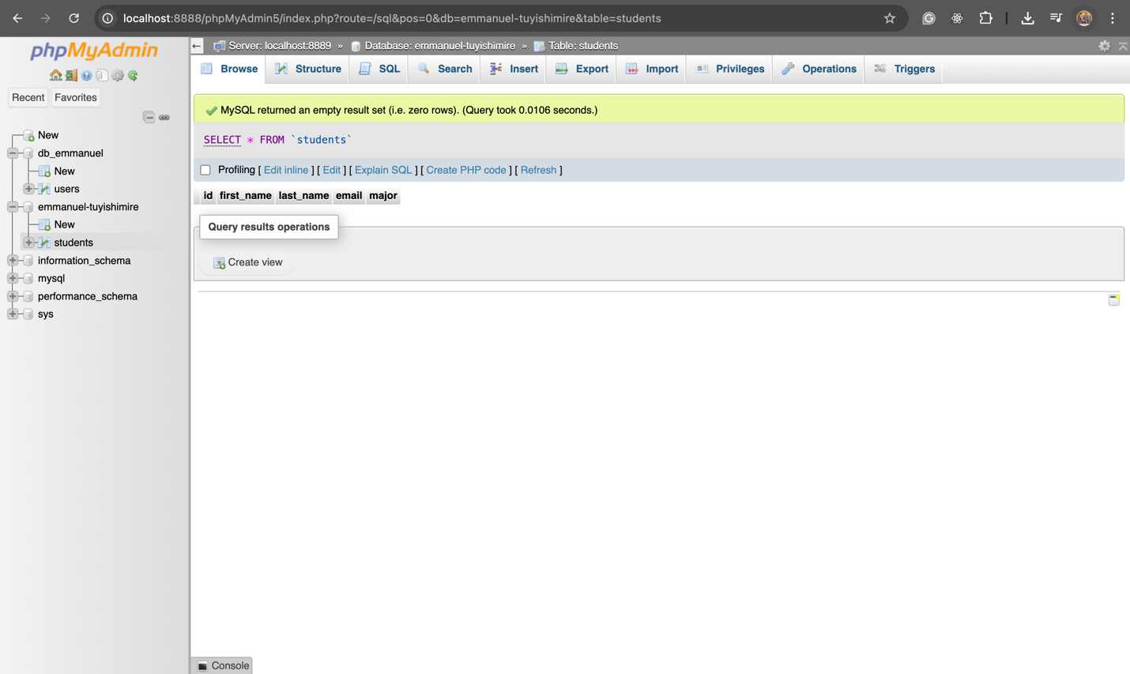

**Exercise 2: Insert data into the table**

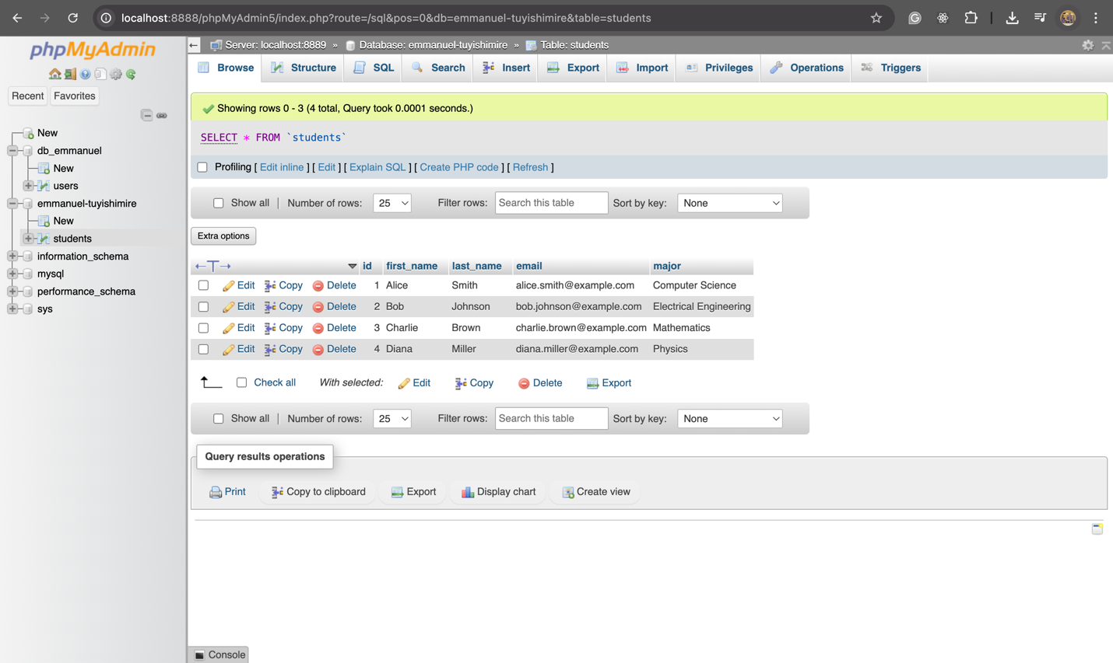

**Exercise 3: UPDATE `students` SET `major` = 'Data Science' WHERE `students`.`first_name` = 'Alice' AND `students`.`last_name` ='Smith';**

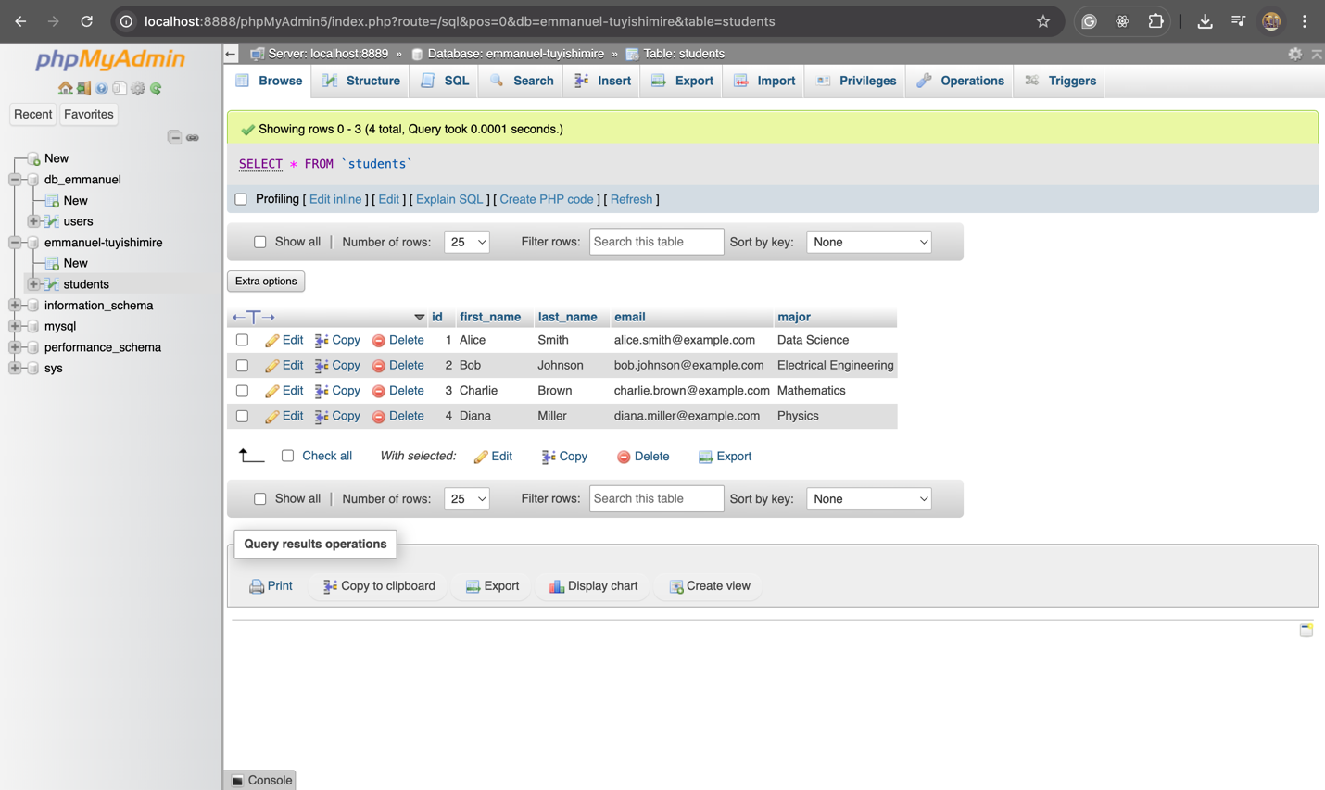

**Exercise 4: DELETE FROM `students` WHERE email = 'charlie.brown@example.com'**

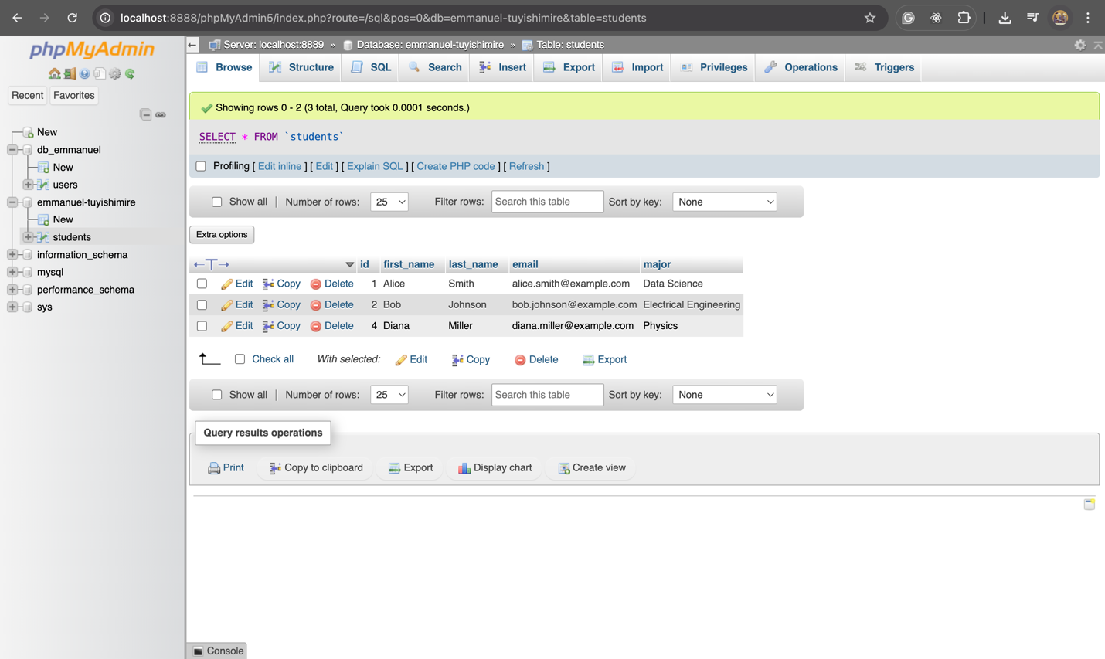

**Exercise 5: SELECT * FROM `students` WHERE first_name LIKE '%C%' ORDER BY email LIMIT 2;**

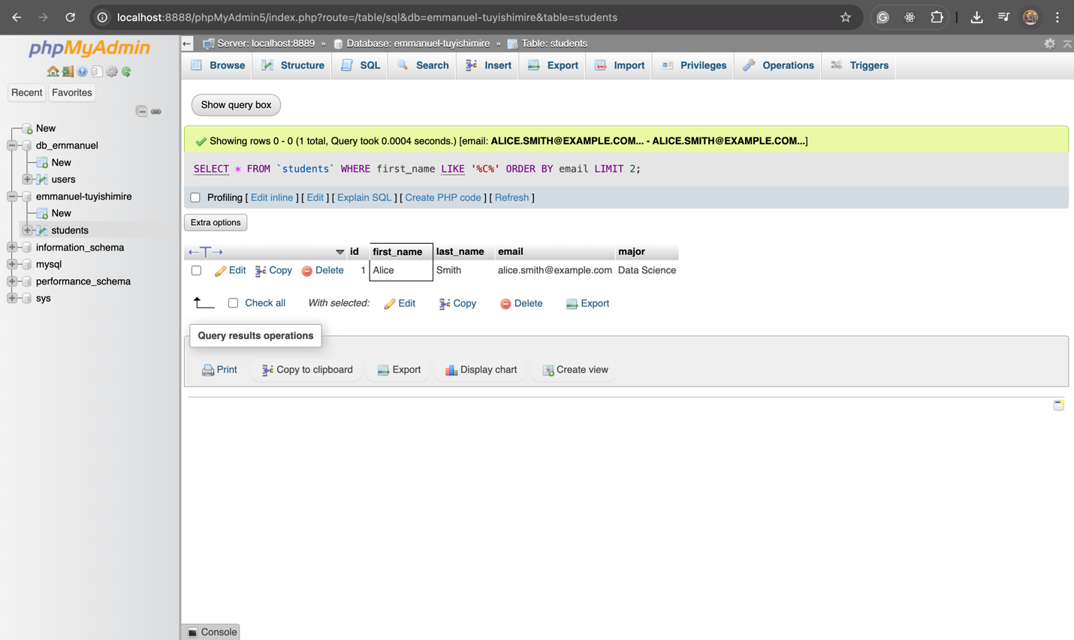

**Exercise 6:** [SELECT](http://localhost:8888/phpMyAdmin5/url.php?url=https://dev.mysql.com/doc/refman/8.0/en/select.html) * FROM `students` WHERE major='Physics';

